
DEPARTMENT OF COMPUTER SCIENCE AND ENGINEERING
CSA1601 Data Warehousing and Data Mining Assignment 2 - CO1

DETAILED ANSWERS: DATA MINING, DATA PREPROCESSING, DISPERSION, REDUCTION AND DISCRETIZATION
Name: Fayza Khatoon.A
Register Number: 192521286
Department: Information Technology
Subject: CSA1601 – Data Warehousing and Data Mining
Academic Year: 2026–2027
Based on the TeleNova, MediCore, e-commerce, smart-meter, university and banking case studies.

IMPORTANT CALCULATION CONVENTIONS
- Q3 quartiles: use the median-of-halves method. For an even number of observations, divide the ordered data into two equal halves and find each half's median.
- Q3 variance: report population variance and standard deviation for the supplied 24 observations; sample estimates are also shown for reference.
- Q4 equal-frequency bins: depth 4 means four bins, with three values in each bin because 12 values are supplied.
- Q5 z-score normalisation: use population standard deviation. Decimal scaling uses j = 6 because the largest absolute income is 150,000 and 150,000 / 10^6 < 1.
- Q6 entropy: binary class entropy uses base-2 logarithms. Candidate split points are midpoints between adjacent values as instructed.
Where the assignment asks for tool verification or implementation results, the report gives the correct procedure and clearly marked result templates. Actual Weka/KNIME/Python screenshots and measured model metrics must be generated by running the student's implementation; they are not invented here.

Q1 – MATCHING BUSINESS PROBLEMS TO MINING FUNCTIONALITIES (5 MARKS)

Mapping the six business problems
Problem | Mining functionality | Learning type / output | Required attributes and source | Candidate algorithms and reason
P1: Plans and add-ons bought together | Association analysis | Unsupervised; frequent itemsets and rules such as  {Plan A} → {Roaming Pack}. | Subscriber/order basket ID, plan ID, add-on IDs, date, channel. Warehouse subscription/billing transactions. | Apriori: clear support-confidence rule generation; FP-Growth: avoids repeated candidate  generation and is efficient for large baskets.
P2: Predict customer churn next month | Classification / prediction | Supervised; probability or class label: churn / no churn. | Historical churn label, tenure, recharge amount, complaints, dropped calls, data usage trend, plan, payment delays. Warehouse  with time-consistent snapshots. | Decision Tree: interpretable churn rules; Random Forest: combines trees and captures non-linear interactions. Logistic  Regression is also a useful baseline.
P3: Natural subscriber usage segments | Clustering | Unsupervised; groups such as low-data, voice-heavy, high-value users. | Monthly data, voice minutes, SMS, recharge, tenure, plan, location.  Warehouse customer-month feature table. | K-Means: efficient for large numeric datasets after scaling; DBSCAN: discovers irregular clusters  and can mark noise, but needs parameter tuning.
P4: SIM cards with unusual calling behaviour | Outlier analysis | Usually unsupervised; anomaly score or flagged SIMs. | Call frequency, duration, destinations, time-of-day, roaming, geographic changes, failed calls. Call  Detail Records (CDR) warehouse. | Isolation Forest: scalable anomaly scoring; Local Outlier Factor (LOF): compares local density and  detects locally unusual behaviour.
P5: Characteristics of high-value vs low-value customers | Concept/class description (characterisation and discrimination) | Descriptive; profiles common traits and contrasts two predefined groups. | Customer lifetime value, ARPU, tenure, plan, usage, recharge, complaints, add-ons. Customer and billing warehouse. | Attribute-oriented induction  / OLAP roll-up: summarises profiles by concept levels; Decision Tree: produces readable rules that distinguish high-  and low-value groups.
P6: Usage change over 24 months | Evolution / trend analysis | Time-oriented; trends, seasonality, growth/decline and change points. | Monthly data usage per customer, month, plan changes, promotions, season, region. Time-series warehouse. | Moving averages / exponential smoothing: reveal smooth trend and seasonality; ARIMA:  models autocorrelation and forecasts future usage.

Why one all-purpose algorithm is unsuitable
The manager's proposal should be rejected. The six problems ask for fundamentally different outputs: association rules, labelled predictions, unlabelled groups, anomaly scores, descriptive profiles and temporal trends. Apriori requires transaction baskets; a classifier requires labelled examples; clustering needs a similarity measure; outlier detection focuses on rare deviations; and evolution analysis uses ordered time observations. No single algorithm optimises all these objectives.
    - Using classification for P3 would require labels that do not exist, contradicting the requirement to discover natural segments.
    - Using clustering for P2 would not directly estimate the probability that a known customer will churn next month.
    - Using association rules for P4 may find co-occurrences but will not reliably rank abnormal SIM behaviour. TeleNova should build an algorithm portfolio selected by business objective, data type, scale, interpretability and validation metric. Common preprocessing and feature stores can be shared, but the mining algorithms and evaluation methods must remain task-specific.

Q2 – THE KDD PROCESS, SYSTEM ARCHITECTURE AND MINING ISSUES (5 MARKS)

KDD steps for MediCore
KDD step | MediCore activity | Example / output
1. Data selection | Select eligible hospital admissions and link records from admission, laboratory, pharmacy and billing systems. Define readmission as a new admission within 30 days after discharge,  excluding planned returns if policy requires. | Patient/admission cohort with unique patient and encounter identifiers.
2. Preprocessing | Resolve duplicate patient IDs, missing values, inconsistent units, coding differences,  impossible dates and conflicting records. Protect identifiers. | Clean, integrated and quality-checked patient table.
3. Transformation | Create features such as age group, previous admissions, length of stay, lab summaries, medication count, diagnosis groups and  discharge destination. Create target label using future 30-day outcome. | One row per index admission, with predictors measured before discharge and a 30-day readmission label.
4. Data mining | Train and compare classification models; optionally use association analysis to find combinations of clinical and service factors. | Readmission risk score, important predictors and candidate patterns.
5. Interpretation / evaluation | Evaluate on a time-separated test set; examine recall, precision, PR-AUC, calibration and subgroup performance. Clinicians review  whether patterns are clinically meaningful. | Validated findings, limitations and decision-support report.

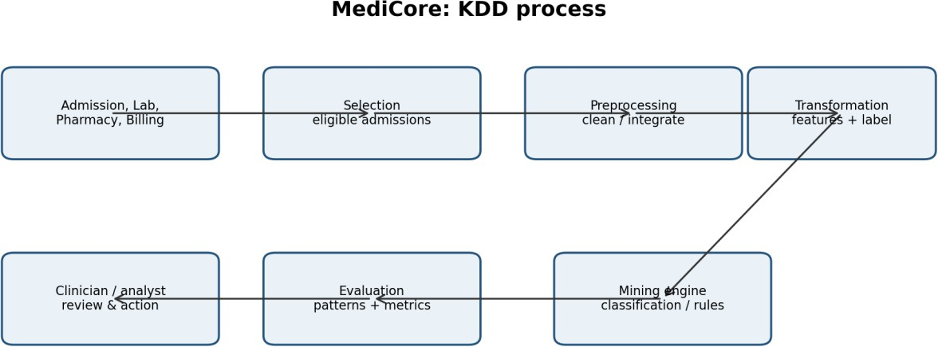

Figure 1: KDD process mapped to MediCore's hospital data.

Typical data mining system architecture
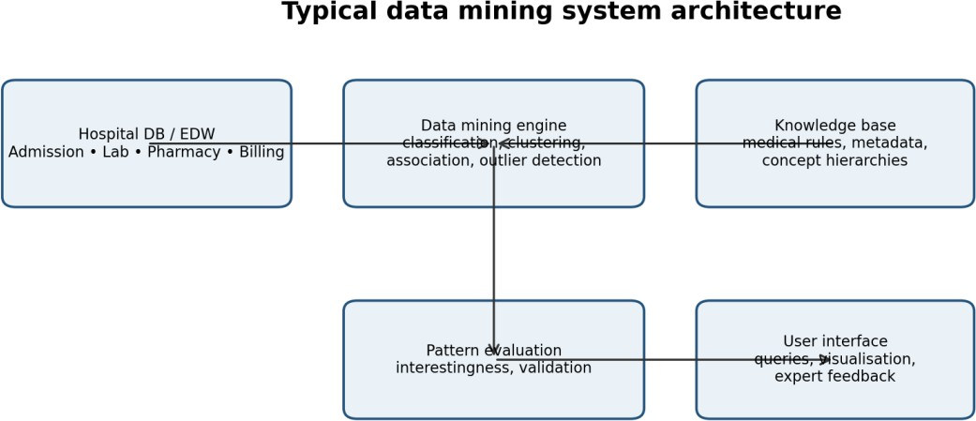

Figure 2: Data mining system architecture and the role of each component.

Component explanation:
    - Database / data warehouse server: stores integrated admission, laboratory, pharmacy and billing data. It provides cleaned, governed data to the mining engine.
    - Data mining engine: contains algorithms for classification, clustering, association, prediction and outlier analysis.
    - Knowledge base: stores medical terminology, diagnosis hierarchies, metadata, constraints and previously accepted patterns. It guides mining and interpretation.
    - Pattern evaluation module: ranks patterns using measures such as support, confidence, lift, accuracy, recall and statistical significance. It filters uninteresting patterns.
    - User interface: allows analysts and authorised clinicians to select data, configure mining tasks, inspect visualisations and provide expert feedback.

Classification of the MediCore mining system
View | Classification for MediCore | Reason
Kinds of data | Relational, transactional, time-series and potentially text data. | Admission, laboratory, pharmacy and billing tables contain structured records; clinical notes  may contain text.
Kinds of knowledge | Classification/prediction, association, characterisation, clustering and outlier patterns. | Main target is 30-day readmission prediction, supported by explanatory patterns and patient  subgroups.
Techniques used | Machine learning, statistical learning, database/OLAP methods and visual analytics. | Models identify complex relationships;  SQL/OLAP integrates and aggregates; visual tools help clinicians inspect results.
Applications | Healthcare analytics, readmission risk  management, resource planning and quality improvement. | The output can help authorised care teams  identify patients who may need additional discharge support.

Data mining issues and mitigations
Issue category | MediCore-specific risk | Mitigation
Methodology and user interaction | A mathematically strong model may identify correlations that clinicians cannot interpret or act upon. | Involve clinicians in defining the target and features; provide explanations, confidence and clinically reviewed reports.
Data quality / integration | Different patient identifiers, units, diagnosis codes and timestamps may produce incorrect joins. | Use a master patient index, standard code mappings, unit conversion, validation rules and data lineage.
Efficiency and scalability | Millions of laboratory and billing events can make repeated mining slow. | Use a warehouse, indexed keys, partitioning, incremental refresh, feature aggregation and  scalable algorithms.
Diversity of data types | Structured lab values, medication events, diagnosis codes and free-text notes have  different formats. | Use type-specific preprocessing, text extraction only where approved, and a documented  common feature model.
Privacy and social issues | Health data is highly sensitive; risk scores may create unfair treatment or stigma. | Apply role-based access, encryption, de-  identification where possible, audit logs, consent/legal review and fairness checks.
Temporal leakage | A feature recorded after discharge may reveal the future readmission outcome. | Use only information available at the prediction  time; use time-based validation and strict feature timestamps.
Class imbalance | Readmissions may be less frequent than non-readmissions, so accuracy may hide poor detection. | Use recall, precision, PR-AUC, class weights and threshold selection; validate on realistic prevalence.

SQL, statistics and data mining are different
SQL retrieves data that a user already knows how to ask for. For example, SELECT COUNT(*) FROM Admissions WHERE readmitted_30_days='Yes' gives the number of readmissions. A statistical summary may calculate the average length of stay for readmitted and non-readmitted groups. These are useful but do not automatically discover complex combinations of predictors.
A mining task can train a decision tree on previous admissions and discover a pattern such as: patients with multiple previous admissions, a long stay and certain discharge conditions have a higher estimated risk of readmission. The model can then score a new eligible admission. Thus, SQL retrieves and aggregates known fields, statistics summarise selected relationships, while data mining searches many attributes for predictive or previously unknown patterns. The model identifies associations, not necessarily causal factors; clinical review is required.

Q3 – DESCRIBING AND COMPARING DATA DISPERSION (7 MARKS)

Central tendency
Ordered data (n = 24): 28, 31, 33, 35, 35, 36, 38, 40, 41, 42, 42, 43, 45, 46, 48, 50, 52, 53, 55, 58, 61, 64, 72, 95.
Mean = Σx / n = 1143 / 24 = 47.625 minutes.
Median = average of 12th and 13th values = (43 + 45) / 2 = 44 minutes. Mode = 35 and 42 minutes; both occur twice, so the data is bimodal.

Midrange = (minimum + maximum) / 2 = (28 + 95) / 2 = 61.5 minutes.
The mean (47.625) is greater than the median (44), indicating a right-skewed distribution. The large delivery time of 95 minutes pulls the mean upward.

Dispersion calculations
Range = 95 − 28 = 67 minutes.
Using the median-of-halves convention: lower half has 12 values, so Q1 = (6th + 7th)/2 = (36 + 38)/2 = 37. Upper half has 12 values, so Q3 = (6th + 7th of upper half)/2 = (53 + 55)/2 = 54.
IQR = Q3 − Q1 = 54 − 37 = 17 minutes.
Population variance: σ² = Σ(x − mean)² / n = 5,119.625 / 24 = 213.318 min².
Population standard deviation: σ = √213.318 = 14.605 minutes. If the 24 observations are treated as a sample, s² = 222.592 and s = 14.920 minutes (divide by n−1).

Five-number summary and outliers
Minimum | Q1 | Median | Q3 | Maximum
28 | 37 | 44 | 54 | 95

Lower fence = Q1 − 1.5×IQR = 37 − 25.5 = 11.5. Upper fence = Q3 + 1.5×IQR = 54 + 25.5 = 79.5. Any observation below 11.5 or above 79.5 is an outlier. Therefore, 95 minutes is an upper outlier.
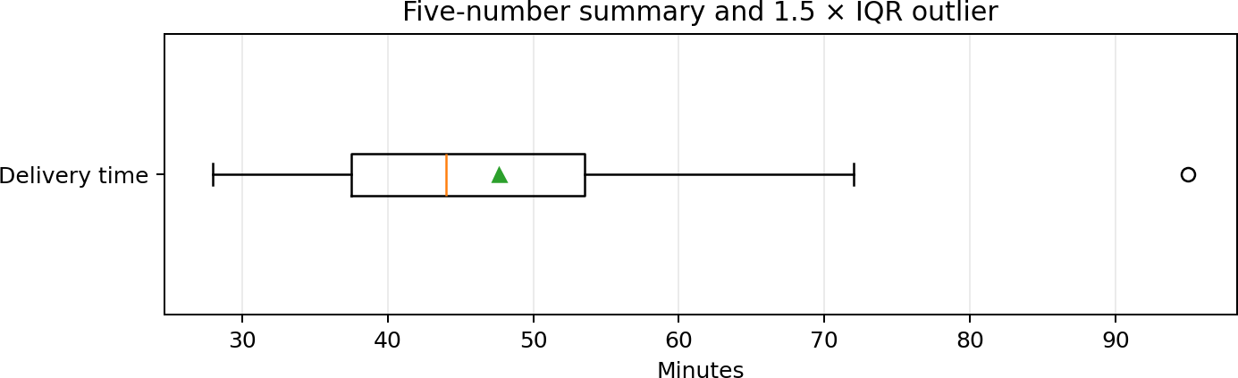

Figure 3: Boxplot of delivery times. The point at 95 minutes lies beyond the upper 1.5×IQR fence.

Recalculation after removing 95
New n = 23 and total = 1,048. Mean = 1,048 / 23 = 45.565 minutes. Median = 12th value = 43 minutes. Mode remains 35 and 42. Midrange = (28 + 72)/2 = 50 minutes. Range = 72 − 28 = 44 minutes.
Using median-of-halves for odd n and excluding the overall median: Q1 = 36 and Q3 = 53; IQR = 17. Population variance = 120.767 min² and population standard deviation = 10.989 minutes.
Measure | All 24 values | After removing 95 | Change / observation
Mean | 47.625 | 45.565 | Falls by 2.060 minutes.
Median | 44 | 43 | Falls by 1 minute.
Mode | 35 and 42 | 35 and 42 | Unchanged.
Midrange | 61.5 | 50 | Falls by 11.5 minutes.
Range | 67 | 44 | Falls by 23 minutes.
Q1 / Q3 | 37 / 54 | 36 / 53 | Each falls by 1 minute.
IQR | 17 | 17 | Unchanged.
Population variance | 213.318 | 120.767 | Falls by about 43.4%.
Population SD | 14.605 | 10.989 | Falls by about 24.8%.

The range and midrange change substantially because both depend directly on the maximum. Variance and standard deviation also fall because 95 is far from the centre. The median, quartiles and mode are more resistant to an extreme observation.

Classification of measures for distributed data
Measure | Class | Reason
Mean | Algebraic | Can be computed from partial count and partial sum, then combined.
Median | Holistic | Cannot be exactly combined from only local medians; generally needs ordered data or richer  summaries.
Variance | Algebraic | Can be combined using count, sum and sum of squares (or equivalent sufficient statistics).
Standard deviation | Algebraic (derived) | Calculate from globally combined variance; local SDs alone cannot simply be averaged.
Range | Distributive | Global minimum is minimum of partition minima; global maximum is maximum of  partition maxima, so range can be derived.

Distributive measures can be combined from the same measure on partitions (for example MIN, MAX, COUNT, SUM). Algebraic measures need a fixed-size set of summary values (for example count, sum and sum of squares). Holistic measures may require all values or an unbounded summary. This matters when warehouse data is split across many partitions.

Tool verification and typical delivery promise
Verification procedure: enter the 24 values into Excel or Python; use AVERAGE, MEDIAN, MODE.MULT, MIN, MAX, QUARTILE and VAR.P/STDEV.P; compare the output with the manual calculations. Python can use numpy.mean, numpy.median, numpy.var(ddof=0) and numpy.std(ddof=0). Quartile values may differ if a tool uses an interpolated percentile convention rather than median-of-halves. State the convention instead of treating the difference as an error.
Recommendation: publish the median of 44 minutes as the typical delivery time because it is resistant to the 95-minute outlier and better represents the central customer experience. Also report the 90th percentile or an agreed high-percentile service time, plus the IQR or a range, because customers and operations need to understand delivery variability. A promise should be based on a service-level percentile and validated over a larger, representative period, not on this small sample alone.

Q4 – CLEANING NOISY AND INCOMPLETE DATA (6 MARKS)

Defects in the sample extract
Meter | Observed issue | Classification | Recommended handling
M102 | kWh is missing. | Missing value | Impute using median/mean for comparable household and time period if justified; otherwise use  model-based estimate and add a missingness flag.
M103 | Region is 'north' rather than 'North'. | Inconsistency | Trim and standardise region labels using a controlled lookup table.
M104 | kWh = −14. | Invalid value / possible sensor fault | Do not treat as a real negative consumption reading unless export/import semantics allow it. Flag and investigate; set missing  only after validation, then impute cautiously.
M105 | Household type is missing. | Missing value | Look up meter registry; if unavailable, use 'Unknown' rather than guessing a class.
M105 | Voltage = 2300 V while other readings are around 230 V. | Likely noise / invalid value / unit or decimal error | Apply physical range validation; quarantine and check source. Do

 |  |  | not automatically convert to 230 without evidence.
M106 | Region is 'S.' rather than 'South'. | Inconsistency / abbreviated value | Map approved abbreviation S. to South using reference data.

M101 (5 kWh, 230 V, North) is plausible. A reading of 5 kWh is low but not automatically invalid; consumption varies by household and hour. In contrast, 2300 V is far outside the expected domestic voltage range and may indicate a scale, decimal, or sensor problem.

Equal-frequency binning (depth 4)
Bin | Values | Bin mean | Smoothed by boundaries
Bin 1 | [5, 9, 11] | 8.33 | [5, 11, 11]
Bin 2 | [14, 18, 19] | 17.00 | [14, 19, 19]
Bin 3 | [23, 26, 27] | 25.33 | [23, 27, 27]
Bin 4 | [30, 33, 38] | 33.67 | [30, 30, 38]

Bin means smoothing replaces each value by its bin mean: 8.33, 8.33, 8.33; 17, 17, 17; 25.33, 25.33, 25.33; 33.67,
33.67, 33.67.
Boundary smoothing replaces each value by the nearest boundary (minimum or maximum of its bin). For the first bin [5, 9, 11], 9 is equally distant from 5 and 11; either boundary may be selected if a consistent tie rule is stated. The table uses the lower boundary for ties.

Regression and clustering for noise
    - Regression: predict a sensor value from related variables such as previous hour's reading, temperature, household type and time of day. A large residual between actual and predicted value flags a possible noisy reading. The prediction should be used only after validation.
    - Clustering: group normal meter readings by similar usage profiles. A point far from its cluster centre or in a low-density region can be flagged as unusual. Clustering is a detection aid, not proof that a reading is wrong.
The −14 kWh value may be an invalid measurement or could represent a special net-export convention; check the meter's data definition. The 2300 V value is an extreme physical-range violation and should be quarantined for source investigation, not smoothed like an ordinary small variation.

Why global-mean imputation can be harmful
Replacing every missing value with the global mean reduces observed variance because each imputed value is placed at the centre of the distribution. It can weaken correlations, hide group differences, create an artificial peak at the mean and mislead clustering or classification. It should be avoided when missingness differs by household type, region or time, when values are strongly skewed, or when missingness itself is informative. Prefer class-wise or model-based imputation with a missingness indicator, fitted only on training data in predictive modelling.

Q5 – INTEGRATION AND TRANSFORMATION OF DATA (7 MARKS)

Part A – Integration conflicts and resolution
Conflict | Admissions source | LMS source | Integrated solution
Entity identification | student_id | sid | Create a canonical StudentKey and a cross-reference table mapping each source identifier to it. Validate  duplicates before merging.
Naming conflict | name | full_name | Map both to canonical attribute StudentName; standardise  whitespace and case without losing original source values.
Format / unit conflict | dob may be DD-MM-YYYY | LMS may use another date format | Parse using source-specific formats and store DOB as a standard DATE

 |  |  | type (ISO internally).
Value conflict | hostel_status may be Y/N | No direct equivalent; LMS may infer campus mode | Use controlled values: Hostel / Day Scholar / Unknown. Do not infer  hostel status from attendance.
Scholarship conflict | scholarship | scholarship_flag | Map to ScholarshipStatus with values Yes / No / Unknown; reconcile conflicts using  authoritative Admissions record and retain source lineage.
Duplicate attributes | student name and scholarship indicators may repeat | full_name and scholarship_flag overlap | Retain one governed canonical field plus source lineage; avoid  storing competing copies without a reason.

Integrated schema example: Student(StudentKey, student_id, sid, StudentName, DOB, HostelStatus, ScholarshipStatus, AttendancePct, Marks, SourceSystem, LastUpdated). A separate source-key mapping table prevents accidental merging of two different students.

Redundancy and correlation
Integration can create redundancy when two source systems describe the same real-world entity or attribute using different names. For example, name and full_name may both represent a student's name. Redundant attributes increase storage, create update anomalies and can give a mining model duplicate signals. Correlation analysis helps identify strongly related numeric attributes; domain knowledge and functional-dependency checks are still required because correlation alone does not prove that two columns are duplicates.

Pearson correlation coefficient
Attendance = {60, 70, 75, 80, 85, 90}; Marks = {52, 58, 66, 70, 79, 85}. Pearson r = Σ[(x−x̄)(y−ȳ)] / √[Σ(x−x̄)² Σ(y−ȳ)²].
Using the six paired observations gives r = 0.9851 (approximately). This is a very strong positive linear correlation: higher attendance is associated with higher marks in this small sample. It does not prove that attendance alone causes higher marks.

Chi-square test: hostel status and scholarship
Observed table: Hostel scholarship=120, no scholarship=180, total=300; Day scholar scholarship=80, no scholarship=320, total=400. Column totals are 200 and 500; grand total = 700.
Expected frequency E = (row total × column total) / grand total.

Cell | Observed O | Expected E
Hostel / Scholarship | 120 | 300×200/700 = 85.714
Hostel / No scholarship | 180 | 300×500/700 = 214.286
Day scholar / Scholarship | 80 | 400×200/700 = 114.286
Day scholar / No scholarship | 320 | 400×500/700 = 285.714

χ² = Σ (O−E)²/E = 33.60. Degrees of freedom = (2−1)(2−1) = 1. Since 33.60 > critical value 3.84 at 0.05 significance, reject the null hypothesis of independence. There is a statistically significant association between hostel status and scholarship in the observed data. This does not establish causation.

Part C – Normalisation of annual family income
Min = ₹20,000; Max = ₹150,000; Mean = ₹67,000; population SD = ₹46,000.

Income | Min-max (0–1) | Z-score | Decimal scaling (j=6)
₹20,000 | 0.000000 | -1.021739 | 0.020
₹35,000 | 0.115385 | -0.695652 | 0.035
₹50,000 | 0.230769 | -0.369565 | 0.050
₹80,000 | 0.461538 | 0.282609 | 0.080
₹150,000 | 1.000000 | 1.804348 | 0.150

Min-max formula: x' = (x−20,000)/(150,000−20,000). Z-score formula: z = (x−67,000)/46,000. Decimal scaling: x' = x/10^6. Decimal scaling uses j=6 because the largest absolute value has six digits and the scaled maximum is 0.15.

Euclidean distance before and after normalisation
Students A=(19 years, ₹35,000) and B=(21 years, ₹80,000).
Before normalisation: d = √[(21−19)² + (80,000−35,000)²] = √[4 + 2,025,000,000] ≈ 45,000.000 minutes/rupees in mixed units. The income scale dominates the age difference.
Min-max ranges: age 17–25; income ₹20,000–₹150,000. A'=(0.25, 0.115385); B'=(0.50, 0.461538).
After normalisation: d' = √[(0.50−0.25)² + (0.461538−0.115385)²] ≈ 0.4270.
This demonstrates that distance-based algorithms such as K-Means and KNN are sensitive to measurement scales. Normalisation prevents income's large numeric units from overwhelming age, although the selected feature weights should still reflect the business problem.

Aggregation, generalisation and attribute construction
    - Aggregation: calculate each student's average monthly attendance or total annual fee payment from lower-level records.
    - Generalisation: replace exact DOB with age group (18–20, 21–23, etc.) or individual hostel building with campus region.
    - Attribute construction: derive AcademicPerformanceBand from marks, or AttendanceRisk = 100 − AttendancePct.
The derivation rule must be documented.

Q6 – DATA REDUCTION AND DISCRETIZATION

Part A – Reduction strategies
Category | Technique | Use for 200 attributes and 5M rows/month
Data-cube aggregation | Aggregate hourly sensor values to minute/hour/day summaries, while retaining raw  readings for failure investigations. | Suitable for dashboards and long-term trend mining; avoid aggregation that hides short  failure spikes.
Attribute subset selection | Forward selection, backward elimination or decision-tree feature importance. | Remove irrelevant or redundant sensor channels; validate selected features against failure recall.
Dimensionality reduction | Principal Component Analysis (PCA). | Transform correlated sensor measurements into fewer components; standardise features first and inspect whether rare-failure signals are retained.
Numerosity reduction | Stratified sampling, histograms, clustering or representative prototypes. | Reduce rows for exploratory analysis; preserve rare failure examples through stratification.
Compression | Lossless compression for archival raw data;  controlled lossy compression for selected summaries. | Reduce storage and I/O. Lossless is safer for audit and exact failure reconstruction.

Sampling methods and rare failures
Sampling method | Description | Advantages / limitations
Simple random without replacement | Select each row at most once, with equal probability. | Simple and representative for common patterns, but may select very few failures.
Simple random with replacement | A row can be selected more than once. | Useful in bootstrap estimation; duplicates may reduce unique information.
Cluster sampling | Select entire groups, e.g. machines or time blocks. | Cheaper when data is distributed by machine; may miss rare failures if selected clusters contain none.
Stratified sampling | Divide into classes/groups and sample each separately. | Ensures rare failure class is represented; proportions can be restored with weights for unbiased population estimates.

If only 0.5% of rows are failures, stratified sampling is most appropriate for model training and evaluation design. Sample failure and normal records separately, retain enough failure cases, and use class weights or training-only

resampling if needed. For final test evaluation, preserve the natural class prevalence so precision and operational performance are realistic.

Number of principal components
There is no fixed number that can be calculated from the question alone because the sensor covariance matrix is not supplied. Standardise the 200 attributes, fit PCA on training data, and retain the smallest number k that explains a chosen cumulative variance threshold (commonly 90–95%). Then validate k against failure-class recall, PR-AUC and stability. If components that explain little total variance carry rare failure signals, retain them or keep selected original attributes alongside PCA components. The objective is not variance reduction alone; it is preserving failure-detection information.

Part B – Equal-width discretization
Minimum = 3; maximum = 44; range = 41. Number of intervals = 4. Equal width = 41/4 = 10.25.

Interval | Values assigned | Count
[3, 13.25) | 3, 7, 7, 9, 12 | 5
[13.25, 23.5) | 14, 14, 15, 18, 21, 21, 22 | 7
[23.5, 33.75) | 25, 25, 27, 31 | 4
[33.75, 44] | 36, 36, 40, 44 | 4

Equal-frequency discretization
Bin | Values | Count
1 | 3, 7, 7, 9, 12 | 5
2 | 14, 14, 15, 18, 21 | 5
3 | 21, 22, 25, 25, 27 | 5
4 | 31, 36, 36, 40, 44 | 5

Equal-width bins cover intervals of the same numeric width but have unequal counts (5, 7, 4, 4). Equal-frequency bins contain the same number of observations (5 each), but their numeric widths differ.

Entropy-based supervised split
Label sequence in value order: N, N, N, N, Y, Y, N, Y, Y, Y. There are five N and five Y, so parent entropy H(S)=−0.5log₂0.5−0.5log₂0.5=1 bit.
Candidate split | Left class counts (N,Y) | Right class counts (N,Y) | Information gain (bits)
11.0 | 1, 0 | 4, 5 | 0.1080
13.5 | 2, 0 | 3, 5 | 0.2365
16.5 | 3, 0 | 2, 5 | 0.3958
20.0 | 4, 0 | 1, 5 | 0.6100
23.5 | 4, 1 | 1, 4 | 0.2781
26.5 | 4, 2 | 1, 3 | 0.1245
29.5 | 4, 3 | 1, 2 | 0.3958
33.0 | 4, 4 | 1, 1 | 0.2365
37.5 | 4, 5 | 1, 0 | 0.1080

Information Gain = H(parent) − [nL/n × H(left) + nR/n × H(right)]. The highest gain is 0.6100 bits at split point 20.0, between values 18 (N) and 22 (Y). Therefore, the best first binary split is Value ≤ 20 versus Value > 20.

Supervised versus unsupervised discretization
Equal-width and equal-frequency binning are unsupervised because they use only the distribution of the values and ignore class labels. Entropy-based discretization is supervised because it uses class labels to choose a split that reduces class uncertainty. For a classification task, entropy-based discretization is often more useful because the intervals are selected to separate classes. It must be learned using training data only to avoid test-label leakage.

Q7 – DIAGNOSE, REDESIGN AND VALIDATE (DAY-4 DESIGN CHALLENGE)

Diagnose the computational / pipeline defects (2 marks)
Original step | Defect and principle violated | How it misleads
1. Replace missing income with global mean | Mean imputation ignores skew, groups and missingness mechanism; preprocessing must preserve distribution and be fitted without  leakage. | Pulls missing values to the centre, reduces variance and may distort risk relationships.
2. Drop occupation with 18% missing | Unjustified attribute deletion; missingness may itself contain information. | Loses potentially predictive information and may bias the population represented.
3. Equal-width income bins | Poor choice for highly right-skewed income; bins may be sparse at high incomes and crowded at low incomes. | Most observations can fall in a few bins; useful differences are hidden.
4. Min-max normalise before train/test split | Data leakage: transformation parameters use test-set information. | Test information influences training pipeline; reported generalisation can be optimistic.
5. Random 10% training sample with 3% defaults | Class imbalance and possibly inadequate  training sample; random split may contain too few defaults. | Model may learn to predict non-default for almost everyone and still show high accuracy.
97% accuracy | Wrong primary metric for rare default class. | A classifier predicting every loan as non-default  already achieves about 97% accuracy while detecting zero defaulters.

Measurable design objectives and constraints
- Primary objective: improve recall for the default class so a larger proportion of actual defaulters are identified.
- Also report precision, F1-score, PR-AUC, ROC-AUC, confusion matrix, specificity and calibration. Accuracy alone is insufficient.
- Set a business threshold: for example, target at least 70% default recall while keeping precision above a level agreed with the bank's review capacity. These are proposed targets and must be adjusted to actual costs.
- Avoid data leakage: split by time or use stratified split before fitting imputation, scaling, feature selection, discretization or resampling.
- Preserve realistic test prevalence; resampling must occur only inside training folds. Keep an untouched test set for final evaluation.
- Meet bank constraints: explainable decisions, reproducibility, auditability, privacy, fairness testing and acceptable scoring latency.

Revised preprocessing strategy
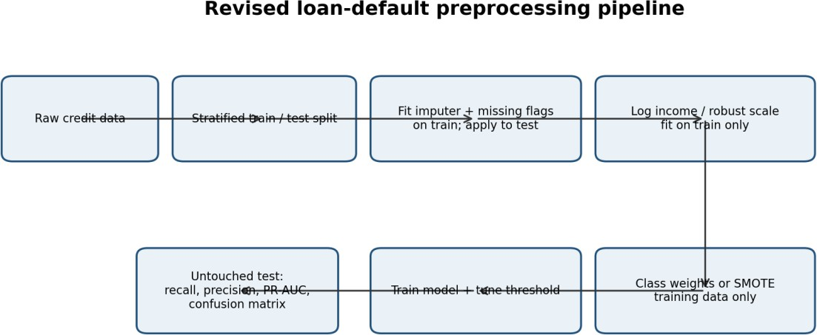

Figure 4: Recommended loan-default preprocessing and validation pipeline.

Order | Revised step | Reason and alternative considered | Fit on training only?
1 | Define target and remove leakage fields; retain outcome window. | Ensure default label is defined consistently and no post-outcome variables are used. | Definition fixed before split; features checked using timestamps.
2 | Split data into train, validation and test; preferably time-based and stratified where feasible. | Time split better reflects future deployment; stratification preserves rare class proportions. Never  preprocess before split. | No transformation fitted yet.
3 | Handle missing income with training median (or log-scale  median) and add IncomeMissing flag. | Median is robust to right skew; global mean is sensitive to extreme incomes. Fit imputer on train only. | Yes; apply learned median to validation/test.
4 | Retain occupation; map missing to 'Unknown' and add OccupationMissing flag.  Optionally compare model-based imputation. | Dropping 18% loses information. Unknown category is transparent and safer than unsupported guessing. | Category vocabulary learned from train; apply consistently.
5 | Transform skewed income using log1p; optionally use quantile transformation or robust scaling. | Log reduces right skew; equal-width bins are not suitable for heavily skewed values. Keep  continuous income if tree model handles it well. | Yes; fit parameters on train only.
6 | Scale numeric features using StandardScaler or RobustScaler for  scale-sensitive models; tree models may not need scaling. | Robust scaling reduces outlier influence; min-max can compress most values when extremes exist. | Yes; fit scaler on train only.
7 | Handle imbalance using class weights or training-only SMOTE/undersampling inside  cross-validation folds. | Class weights preserve original observations; SMOTE may create synthetic patterns and must never  touch test data. | Training folds only.
8 | Select features using training-fold feature importance, regularisation  or mutual information. | Reduces noise while preserving occupation and income signals;  avoid selecting on test outcomes. | Yes; within cross-validation.
9 | Train baseline and candidate models; tune decision threshold on validation data. | Compare Logistic Regression, Decision Tree / Random Forest or  Gradient Boosting; threshold can trade precision against recall. | Model and threshold fitted using train/validation only.
10 | Evaluate once on untouched test data and document results. | Use confusion matrix, recall, precision, PR-AUC, ROC-AUC, F1 and calibration; monitor by  subgroup. | Test is used only for final evaluation.

Predictions before implementation (1 mark)
- Income dispersion: median imputation alone would still reduce variance, but log1p and robust treatment should reduce the influence of the high-income tail. The transformed distribution should be less right-skewed; retain the original income for interpretation.
- Training class distribution: stratified splitting preserves approximately 3% defaults and 97% non-defaults. If SMOTE is used, the training distribution becomes less imbalanced; validation and test retain the natural prevalence.
- Accuracy versus recall: accuracy may decrease slightly because the model will identify more risky loans instead of predicting the majority class for nearly all records. Recall for defaulters should improve; precision may decrease depending on threshold.

Implement and validate the redesign (2 marks)
Use a public credit dataset such as UCI German Credit or another approved credit-risk dataset. Ensure the target definition and class prevalence are documented. Run the original pipeline and redesigned pipeline using exactly the same held-out test records. The German Credit dataset has a different size and class balance from the scenario's 3% default rate, so report its actual prevalence and do not claim it reproduces the bank's data distribution.
Suggested Python implementation outline:
  - Load data and define target y (default=1, non-default=0).

  - Split train/test using a time split if dates exist; otherwise use stratified train_test_split.
  - Build a ColumnTransformer: numeric median imputation + missing indicators + log/robust scaling; categorical most-frequent or Unknown imputation + one-hot encoding.
  - Use class_weight='balanced' where supported, or apply SMOTE only within an imbalanced-learn Pipeline on training folds.
  - Fit candidate models and tune the classification threshold on validation data.
  - Evaluate on the untouched test set with confusion_matrix, classification_report, average_precision_score and ROC-AUC.
Metric | Original pipeline (fill after run) | Redesigned pipeline (fill after run)
Accuracy
Default-class recall
Default-class precision
F1-score
PR-AUC / Average Precision
ROC-AUC
True positives / false negatives
False positives

Do not fill this comparison with guessed numbers. Include screenshots of the dataset, pipeline settings, confusion matrix and metric output from Python, Weka or KNIME. If using Python, keep the random seed and split fixed so both pipelines use the same test set.

Defend the final design and remaining risk
The redesigned pipeline is preferred because it preserves useful occupation information, treats skewed income more appropriately, prevents test-set leakage and addresses the rare default class. A decrease in accuracy is acceptable if defaulter recall and expected business value improve without overwhelming investigators with false positives. The final threshold should be selected using the relative cost of missed defaults and manual review.
One remaining risk is concept drift: borrower behaviour, economic conditions and lending policies may change after deployment. The bank should monitor default prevalence, recall from matured outcomes, calibration, feature drift and subgroup performance, and retrain only after controlled validation. Fairness and regulatory review remain necessary.

OVERALL CONCLUSION
This assignment demonstrates the use of data mining functionalities and the KDD process, along with data cleaning, integration, transformation, reduction and discretization. The numerical examples show how dispersion measures react to outliers, how missing and noisy values should be treated, how correlation and chi-square support redundancy and association analysis, and how normalisation changes distance calculations. Sampling, PCA and discretization reduce data complexity, while the loan-default challenge shows why leakage control and class-imbalance-aware evaluation are essential. All tool-based verification and Q7 model metrics should be completed with actual execution evidence.

REFERENCES
- 1. CSA16 Data Warehousing and Data Mining, Assignment 2 – CO2, user-provided assessment brief.
- 2. Jiawei Han, Micheline Kamber and Jian Pei, Data Mining: Concepts and Techniques.
- 3. Ian H. Witten, Eibe Frank, Mark A. Hall and Christopher J. Pal, Data Mining: Practical Machine Learning Tools and Techniques.
- 4. KNIME Analytics Platform documentation – data preprocessing, statistics and modelling nodes.
- 5. scikit-learn documentation – preprocessing, model selection, classification metrics and PCA.

